PRESS RELEASE

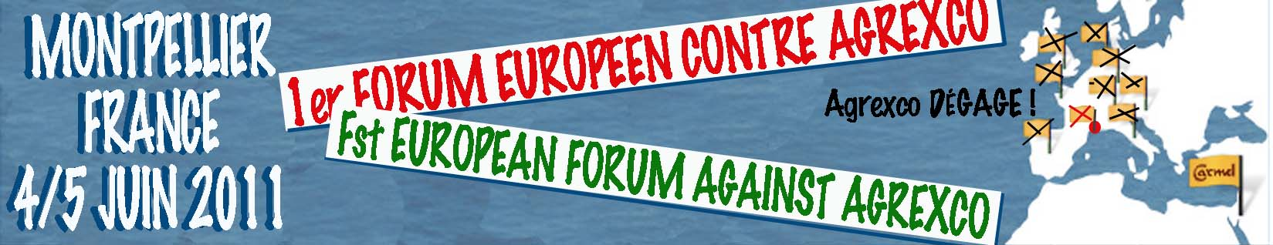

The first European Forum of the campaigns against Agrexco took place in Montpellier (France) the 4 and 5 June 2011. Organised by the French coalition against Agrexco and the Palestinian BNC (Boycott National Committee), it brought together 22 foreign delegates from 7 European countries (Switzerland, Italy, United Kingdom, Netherlands, Belgium, Germany, Catalonia) as well as 90 delegates from all around France. The Norwegian and Swedish campaigns could not send delegates but wrote support messages.

Along with Rafeef ZIANAH, representative of the BNC, Michael DEAS, European coordinator for the BNC, and 3 Palestinian lawyers from the Palestinian Bar Association in Ramallah, the delegates worked on the two main topics of the campaigns against Agrexco: the boycott of Agrexco and the legal offensive against Agrexco. They exchanged experiences and discussed practical means of action in an friendly atmosphere of mutual cooperation.

The forum exposed the existence of a very active European mobilisation against Agrexco and broad agreement with the call for boycott from the Palestinian BNC. The forum agreed to establish a European wide network and to call for a European day of action against Agrexco on Saturday 26 November 2011.

Montpellier, 5 June 2011

